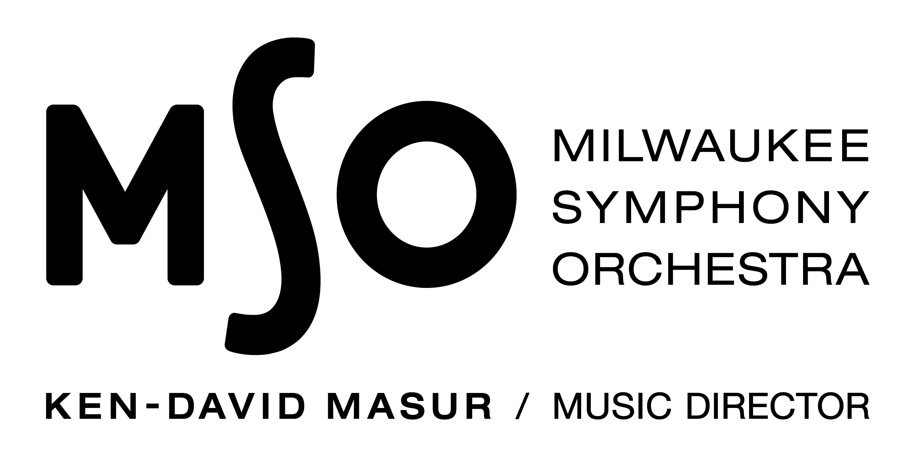

Magnificent Mozart
MSO TEEN CHORAL PARTNERS CONCERT 2022

PROCEDURES FOR APPLICATION AND SELECTION OF HIGH SCHOOL CHORAL PERFORMING GROUPS

PLEASE NOTE: We understand that the conditions caused by COVID-19 have greatly impacted choral programs over the last two school years. Please fill out the information requested to the best of your ability. If you have any questions, or would like to discuss your particular situation further, please contact us at 414-226-7885 or edu@mso.org. This form is being supplied as a Word doc so you can easily type into it and email back to us.

- Application, repertoire list, and recordings* should be sent by email to the MSO no later than June 21, 2021 (if you would like to apply, but sending materials digitally or the deadline presents an issue, please contact us to discuss your situation). Please send materials to: edu@mso.org with the subject line Teen Choral Partners

- The current choral director must be the director for the 2021.22 season.

- Application: This year the application contains questions about what your choral program looked like before the pandemic, how you were able to function during the pandemic, and how you would approach participating in the Teen Choral Partners program. Responses to these questions will be helpful to us as we determine who the participants of the 21.22 program will be.

- Repertoire Lists: Please supply a list of repertoire that your chorus has done in the recent past. We recognize that amount and types of repertoire, as well as the format in which it was presented, may have been greatly impacted by the COVID-19 pandemic. We suggest creating a list of highlights including pieces from the 18-19 school year to the present in the following format:

Sunrise Mass, Ola Gjeilo Live performance, May 2019
“Abide With Me”, arr. Smith Virtual performance created November 2020
“Sicut Cervus”, Palestrina Performed live (streamed to audience), April 2021

If you wish to include any additional notes about your repertoire to give context you are welcome to do so.

- *Recordings: We recognize that many choral programs may not be able to provide recent recordings that are an accurate reflection of their quality or capability. While submitting recordings is welcomed, it is not required to apply for the 2021.22 program. If you choose to submit recordings, please see the parameters below.

- All materials and recordings* will be evaluated by the MSO in a blind screening.

- Invitations to perform with the Milwaukee Symphony Orchestra will be issued by July 16, 2021. Results will be emailed to the chorus director’s school AND home email address. Please supply both.

- Selected schools will receive concert and rehearsal details by September 15, 2021. The purchase of music will be the responsibility of the schools.

SUMMARY OF DATES & DEADLINES

June 21, 2021 | Applications, repertoire lists, and recordings* due to MSO Education Dept.
July 16, 2021 | Invitations to perform will be emailed to selected schools
September 15, 2021 | Selected schools will receive concert and rehearsal details.
December 2021 | Ensemble biographies and pictures for selected groups due to MSO
January/February 2022 | Conductor holds in person rehearsal at each participating school
February TBD, 2022 | Bradley Symphony Center, Milwaukee  Piano/Conductor Rehearsal for all choruses, Time TBD
March 8, 2022 | Bradley Symphony Center – Orchestra rehearsal  Time TBD
March 9, 2022 | Bradley Symphony Center – MSO Teen Choral Concert  9:00 a.m. warm-up, 10:30 a.m. performance

212 W Wisconsin Ave
Milwaukee, WI 53203
Telephone: 414.226.7886
Email: edu@mso.org

APPLICATION TO PARTICIPATE IN MSO TEEN CHORAL PARTNERS CONCERT - 2021-2022 SEASON

Please print or type.

SCHOOL:
SCHOOL ADDRESS:
CITY/STATE/ZIP:
SCHOOL PHONE:
PRINCIPAL:
SUPERINTENDENT:
CHORAL DIRECTOR:
HOME/CELL PHONE:
HOME ADDRESS:
(Home contact information is requested so we may contact you over the summer)
WORK EMAIL:
HOME EMAIL:
NAME OF ENSEMBLE:
TOTAL NUMBER OF PARTICIPANTS EXPECTED FOR MSO TEEN CHORAL CONCERT:
SA: TB:

PLEASE ANSWER THE FOLLOWING QUESTIONS:
- Please describe your choral program prior to the pandemic. How many students were involved? What ensembles were offered? Describe some of the highlights of the program, such as memorable performing experiences, awards received, or tours or travel opportunities your program engaged in.

- Please describe how your choral program adapted to the conditions caused by the COVID-19 pandemic. Were you able to meet and if so how? Did the pandemic affect your enrollment? Were you able to perform in some way (virtually, in person with mitigations, etc.)? What are you most proud of during this time?

- As your program emerges from the pandemic, what will you focus on? How would participating in the MSO’s Teen Choral Partners program contribute to your program goals for the next year? How would you prepare your students for participation?

*RECORDINGS (Optional in 2021.22)
This year submitting recordings is optional. If you choose to do so, you may submit up to two (2) recordings. They can be audio or video. This year you are welcome to submit whatever you feel is the best representation of your group’s recent work. If you are sending large files, we suggest sending to us via WeTransfer.com, a free file transfer site.

LIST WORKS YOU ARE SUBMITTING. You may submit up to two (2):
SELECTION 1:
- Title:
- Composer:
- Recording date:
- Format (i.e. live performance, virtual performance, etc.):
- Number of students heard on the recording:
SELECTION 2:
- Title:
- Composer:
- Recording date:
- Format (i.e. live performance, virtual performance, etc.)
- Number of students heard on the recording:

Acceptance into the program will be contingent upon the signing of a Statement of Understanding by the choral director, school principal, and district superintendent, stating the following:

- We understand that all expenses, travel risk, and chaperonage of our group are to be covered entirely through our local efforts.
- We understand that the orchestra rehearsal and concert performances are during the school day. The piano rehearsal may also be scheduled during the school day (Dates and times to be provided by the MSO)

